**How to Choose the Right Reporting and Analysis Tools to Suit Your Style**

**Microsoft Business Intelligence Technical Article**

**Authors**

**Hitachi Consulting:**

John Lauer – Primary Author

Scott Cameron – Revising Author

Jeff Nelson – Supporting Author

Victor Rocca – Supporting Author

Harlan Smith, Derrick Nation, Hilary Feier, Liz Vitt, Jim Adams, David Punnett, Greg Humphreys – Reviewers

**Microsoft:**

Ariel Netz, Joe Wallace, Carolyn Chau – Reviewers

**Published:** “How to Choose the Right Business Intelligence Technology to Suit Your Style”, January 2011

**Revised:** April 2012

**Applies to:** SQL Server 2012

**Summary:** This white paper provides information that will help business and IT decision makers select the right Microsoft reporting and analysis front-end tools based on their business users’ intent: self-service reporting, data mashups, professional reporting, dashboarding, and scorecarding.

**Copyright**

This document is provided “as is.” Information and views expressed in this document, including URL and other Internet website references, may change without notice. You bear the risk of using it.

This document does not provide you with any legal rights to any intellectual property in any Microsoft product. You may copy and use this document for your internal, reference purposes.

© 2012 Microsoft Corporation. All rights reserved.

Contents

Introduction 5

Self-Service Reporting and Analysis 7

Description and Key Characteristics 7

Tool Options 7

Microsoft Excel 2010 7

Microsoft SQL Server 2012 Reporting Services Power View 8

Typical Infrastructure 9

Key Considerations 10

Case Study 10

Customer Description 10

Business Problem 10

Tool Choice and Solution Architecture 10

Benefits Realized 11

Summary 11

Self-Service Data Mashups 12

Description and Key Characteristics 12

Tool Options 12

Microsoft Excel 2010 and Microsoft SQL Server 2012 PowerPivot 12

Typical Infrastructure 14

Key Considerations 14

Case Study 15

Customer Description 15

Business Problem 15

Tool Choice and Solution Architecture 15

Benefits Realized 16

Summary 16

Professional Reporting 17

Description and Key Characteristics 17

Tool Options 17

Microsoft SQL Server 2012 Reporting Services 17

Typical Infrastructure 18

Case Study 19

Customer Description 19

Business Problem 19

Tool Choice and Solution Architecture 19

Benefits Realized 20

Summary 20

Performance Monitoring (Dashboards) 21

Description and Key Characteristics 21

Tool Options 21

Excel Services / PowerPivot for Excel 21

Microsoft SQL Server 2012 Reporting Services Power View 22

PerformancePoint Services 22

Microsoft SQL Server 2012 Reporting Services 23

Typical Infrastructure 24

Key Considerations 24

Case Study 25

Customer Description 25

Business Problem 25

Tool Choice and Solution Architecture 25

Benefits Realized 25

Summary 26

Scorecarding 27

Description and Key Characteristics 27

Tool Options 27

Excel and PowerPivot for Excel 27

Reporting Services 27

PerformancePoint Services 27

Key Considerations 29

Case Study 29

Customer Description 29

Business Problem 29

Tool Choice and Solution Architecture 30

Benefits Realized 30

Summary 30

Conclusion 31

Additional Resources 32

For More Information 33

# Introduction

Abraham Maslow was once quoted as saying “If you only have a hammer, you tend to see every problem as a nail.” Those words are more true than ever before as an increasingly complex and interconnected world makes selecting the right business intelligence (BI) reporting and analysis tool crucial. Businesses, in an effort to stay one step ahead, collect large amounts of data ranging from demographics, buyer behavior, and customer loyalty to financial and operational data. Unfortunately the data is useless for decision making, its intended purpose, without a way of organizing and displaying it as meaningful information. To help digest and make sense of their data, companies need to select the proper reporting and analysis tools that can present data in a relevant and timely manner. With the wide variety of tools available in the marketplace today, it is easy to get confused as to which to pick. But, just as a hammer is not appropriate for all jobs, no single business intelligence tool is appropriate for every user’s need. Companies need a way to determine which tools are most suitable to meet the varied needs of their users. The good news is that Microsoft provides a variety of tools, Microsoft Excel and Excel Services, Microsoft PowerPivot, Microsoft SQL Server Reporting Services (including Power View), and Microsoft SharePoint PerformancePoint Services, with the intent of addressing a broad range of reporting and analysis styles. All of these tools can be surfaced through the familiar SharePoint Server interface. For more information about the components of the Microsoft BI solution, see [the Microsoft BI Homepage](http://www.microsoft.com/bi) (http://www.microsoft.com/bi).

In this paper, *style* is a term that describes a user’s reporting and analysis intent: the user’s unique information needs and how the user wants to interact with, present, and share information. These styles are also defined by the organization’s infrastructure and the skill sets of both business users and IT. This white paper discusses five different reporting and analysis styles:

* **Self-Service Reporting and Analysis** – Self-service reporting and analysis empowers users who don’t have specialized skills to explore data and experiment with presenting information in a variety of ways. They can discover new insights, find persuasive ways to display data, and share their reports and presentations with colleagues without having to rely on IT or others.
* **Self Service Data Mashups** – Data mashups are created by combining data from multiple sources: a data warehouse, reports, spreadsheets, web sites, and so on. After the data is coalesced, analysts will want to gain deeper insights by pivoting and drilling down into the information. These business users need to be able to work independently of IT because data mashups must often be performed quickly, or they may only be used for one-time analysis.
* **Professional Reporting** – Professional reporting is characterized by highly formatted reports that usually follow a pixel-perfect format and rendering style and are deployed to an IT managed environment that provides consistency, scalability, manageability, security, and automated distribution.
* **Performance Monitoring (Dashboards)** – This style describes dashboard-style reports that enable users to quickly and easily monitor the performance of their business. This style is catered to executive level or department leadership who require at-a-glance visibility on the health of the business, but it often also permits further investigation via interactivity.
* **Scorecarding** – Scorecarding is a style that describes highly summarized views with key performance indicators (KPIs) measured and scored against predefined targets such as a balanced scorecard. This style is generally a part of a performance management program, though it can also be used to measure operational performance.

This white paper provides business and IT decision makers a practical guide on how to identify both which reporting and analysis style is being used and the tools that best fit each of the styles. The most suitable tool can be selected by aligning the user’s intent or style with a reporting and analysis tool designed for a similar intent and that matches the organization’s reporting capabilities, infrastructure, and skill sets. The white paper outlines the following:

* The key characteristic of the BI style (**Description and Key Characteristics** section)
* The tool options to consider along with the recommended best fit for the characteristics of the style (**Tool Options** section)
* Information about the typical infrastructure used to support the BI style (**Typical Infrastructure** section)
* Key considerations that will help you decide which tool or tools are most suited for your needs (**Key Considerations** section)
* A case study that highlights how the best fit technology was used to support that style (**Case Study** section)

By utilizing this information, you will be better prepared to make a decision and feel confident you are choosing the right tool or tools for your solution.

# Self-Service Reporting and Analysis

## Description and Key Characteristics

The best analysts, and often the best assets, in most organizations are those users who love to dig into the data and really understand why the business is performing the way it is. These users need to work independently of IT so that they can quickly analyze data from multiple perspectives by creating and manipulating a variety of tables, charts, and other data visualizations. After their analysis is complete, they want to share their findings in a report or include them in a presentation. Whether they are drilling into sales data to understand why a store in the Southeast is outperforming all the other stores or quickly creating a revenue forecast report for an executive presentation, these users are engaging in the “Self-Service Reporting and Analysis” style of BI. Some common characteristics of this style are:

* Users are executives, managers, information workers, and analysts who want to quickly create reports and data visualizations.
* Users are familiar with the business data and able to access enterprise and department data sources.
* Users want to drill down, pivot, filter, and present the data in tables, charts, and other visualizations.
* Users want to include their reports and visualizations in presentations or informally share them with other team members, but distributing the information on a regular basis is not typically the primary purpose of this style.
* Users are comfortable with Microsoft Excel and drag-and-drop report design interfaces, but are not familiar with query languages such as SQL and Multidimensional Expressions (MDX).

## Tool Options

Microsoft Excel 2010 and Microsoft SQL Server 2012 Reporting Services Power View are excellent tools for supporting the self-service reporting and analysis style.

### [Microsoft Excel 2010](http://blogs.technet.com/b/office2010/archive/2010/01/28/business-intelligence-features-in-excel-2010.aspx)

Microsoft Excel is the most widely deployed BI tool in the world for the self-service reporting and analysis style. Virtually all users are familiar with Excel, and this is a comfortable environment for analyzing data and developing reports quickly.

Excel can be used to explore data and create reports using SQL Server Analysis Services, SQL Server, and other data sources. In particular, Excel is an excellent tool to use to analyze Analysis Services data because Excel PivotTables and PivotCharts make available all of Analysis Services features. The user-defined hierarchies, key performance indicators (KPIs), perspectives, drill-through and reporting actions, writeback, calculations, and formatting that have been configured in Analysis Services are all accessible in an Excel PivotTable report. The identity used to connect to the cube is used by the role-based security in Analysis Services to determine what data can be displayed in the report. After the user has explored the data using a PivotTable’s ability to drill down, pivot, and filter data, the user can use Excel slicers and advanced formatting capabilities to create sophisticated reports.

Excel reports can be distributed to others via email or published to SharePoint Server and viewed by using Excel Services in Microsoft SharePoint Server 2010. Excel Services is a Microsoft SharePoint Server technology that enables users to publish whole or partial Excel workbooks to SharePoint Server. This gives users access to the workbook or specific parts of it without allowing them to modify the workbook or calculations, thereby ensuring that a single version of the workbook is maintained and viewed by all users. Users of an Excel Services workbook are also able to perform live, interactive analysis through any browser, including sorting and filtering of data, as well as PivotTable drill-down/drill-up. An Excel Services workbook has the added benefit of ensuring the right access and distribution while maintaining a single version of the truth. Additionally, users can create distribution lists to automate distribution of the information, and they can use the versioning capabilities in SharePoint Server to facilitate collaboration. Alternatively, users can distribute the Excel workbooks via email for quick and easy sharing, though by this method every user can modify the workbook, and maintaining a single version of the truth becomes almost impossible. For this reason, Excel Services is recommended for workbook distribution instead of email.

### [Microsoft SQL Server 2012 Reporting Services Power View](http://social.technet.microsoft.com/wiki/contents/articles/3726.power-view-overview.aspx)

Power View, a new feature in SQL Server 2012 Reporting Services, enables users of all skill levels to explore their data and easily create highly formatted reports containing sophisticated visualizations.

Power View supports self-service analysis by empowering users to perform reporting and analysis tasks that previously required the skill set of a professional report developer. A user can easily analyze data from PowerPivot or Analysis Services 2012 using drag-and-drop techniques. The data is initially displayed as a familiar table; with a single click the user can transform the “shape” of the data into a variety of charts as shown in Figure 1. The user can then enrich the report by adding slicers, filters, tiles, small multiples, and timed animations. Small multiples use an attribute in the data to “slice” a single chart into multiple smaller charts that reveal hidden relationships. Timed animations enable a user to can create a “live-action” chart showing the data changing through time to quickly identify trends and anomalies. The user can further analyze their data by adding more visualizations to the current view (page) or by adding more views to the report. Because the relationships in the data are contained in PowerPivot or Analysis Services, Power View can apply interactive filtering to all of the tables and charts in a view.

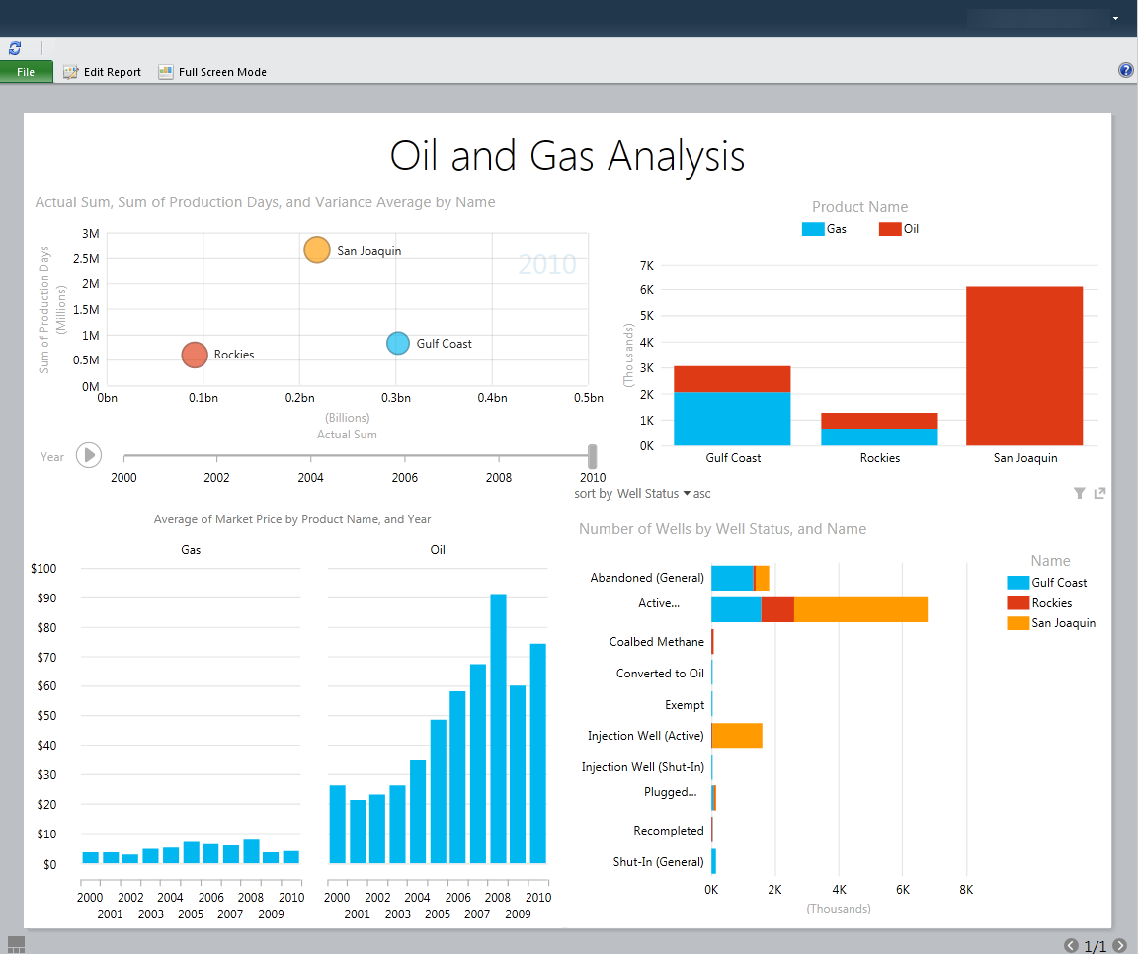

Figure 1 – Power View report displaying a variety of easily created charts

Reports in Power View are created in an environment that is familiar and easy to use. It is an interactive web-based application launched from SharePoint Server 2010, and it uses the familiar Microsoft Office ribbon. There is no guesswork or switching between design and preview mode because the user always sees formatted data exactly as it will appear. Effects of any change made to the report are shown immediately. After a report is completed it can be saved, secured, and shared in SharePoint, exported to an interactive version of the report in PowerPoint, or printed.

## Typical Infrastructure

Users engaged in self-service reporting and analysis can create and share reports with little to no direct IT involvement. However, IT plays an important role by providing and managing supporting infrastructure. Typical infrastructure includes a collaboration portal, report distribution, and department and enterprise databases. To enable users to share Excel workbooks and create Power View reports, IT needs to implement SharePoint Server 2010 Enterprise Edition with SQL Server 2012 Reporting Services installed in integrated mode and Excel Services enabled. IT-managed Analysis Services databases invite analysts to explore and report on this data using Excel PivotTables and PivotCharts. IT can also ease access to data contained in PowerPivot or Analysis Services tabular models by publishing connection files in SharePoint.

## Key Considerations

The questions in the following table may help you identify how to make the best use of Excel and Reporting Services Power View for self-service reporting and analysis.

|  | **Excel** | **Power view** |
| --- | --- | --- |
| **What is your primary intent?** | We need to perform analysis and presentation of small to medium-sized data sets and Analysis Services data. | We need the ability to easily create highly formatted data visualizations. |
| **What is the skill level of the users creating reports?** | Users can work with complex reports with interactive cross-filtering, and they are familiar with PivotTables and PivotCharts to analyze Analysis Services data. | Users can use a simple drag-and-drop interface to create sophisticated visualizations. |
| **Do you require asymmetrical or highly customized report layouts?** | Yes.  Excel’s flexible table and chart layout capabilities meet our needs. (Note: Excel reporting usually requires manual pagination.) | Yes.  In Power View, users can easily create asymmetrical and highly customized report layouts that are presentation-ready. |

## Case Study

### Customer Description

Great Western Bank, a subsidiary of National Australia Bank, offers banking, loan, and credit-card services and holds U.S. $8.2 billion in assets. With about 402,000 customers and 200 branches, the company is one of the 100 largest banks in the United States.

### Business Problem

Great Western Bank has expanded by more than 300 percent since its purchase by National Australia Bank in 2008. The bank once used a third-party reporting solution and exported data to unmanaged spreadsheets for analysis. As the bank’s data volume grew, users struggled with the old reporting tools and had to wait as long as a week for help-desk assistance. As a result, it was difficult for bank officers to cross-sell additional services or to identify dissatisfied customers. With a goal of expanding another 300 percent by 2014, the bank needed innovative business intelligence (BI) tools to help it retain existing customers, compete for new ones, and maximize profitability.

### Tool Choice and Solution Architecture

Great Western Bank deployed a data-warehousing and BI solution based on Microsoft SQL Server 2012 Enterprise data management software. The bank used Microsoft SQL Server 2012 Integration Services to connect a new data warehouse to the bank’s disparate data sources, including a mainframe IBM DB2 database. The data warehouse was designed to eventually hold about 6 terabytes of data.

Bank employees now use Power View to explore, visualize, and present data. Users can store and share Power View reports in a Microsoft SharePoint Server 2010 portal. Eventually, all 1,500 bank employees will use BI information from the solution, with about 300 of them regularly performing custom queries.

Administrators use SharePoint Server 2010 tools to monitor data source usage and server performance. With Microsoft SQL Server 2012 Data Quality Services, they impose standard definitions, automate data-cleansing tasks, and take other centralized data-quality improvement actions.

### Benefits Realized

With the Microsoft solution, Great Western Bank can improve insight, strengthen relationships, and meet growth goals.

It’s now fast and easy for nontechnical employees to get exactly the information they are looking for, such as lists of various categories of account holders for marketing campaigns or decision-making meetings. Power View gives users an intuitive, safe environment where they can manipulate data and perform what-if analysis in minutes instead of days without needing help-desk support. The Microsoft solution helps IT administrators retain oversight of the BI system and protect critical tools without hampering users’ creativity.

Because users can now access so much more information about all aspects of the bank’s operations, it is easier for them to ensure a better fit between customers and bank services. Power View helps bankers fully comprehend the customers’ needs, serve existing and new customers more effectively than ever, and maximize account-level profitability.

## Summary

Excel meets the basic needs of performing quick analysis of small to medium sized data sets. It is also a powerful tool for analyzing server based data, particularly Analysis Services databases. Users can easily create and share reports, and the familiar interface minimizes the learning curve and enables the user to focus on exploring data quickly and easily.

Reporting Services Power View enables users at all skill levels to easily create visual presentations in stylish, fixed-format reports. Based on PowerPivot or Analysis Services tabular models containing integrated data and embedded metadata, users are able to create Power View reports using simple drag-and-drop techniques.

# Self-Service Data Mashups

## Description and Key Characteristics

Exponential growth in the volume of data is not the sole characteristic of the “data explosion”. In the era of the data explosion the number and location of data sources, the ability to discover and access data covering a growing number of subject areas, the speed at which data is available, and the power of readily available computer resources to process and analyze data have all experienced revolutionary growth. Any business that wants to have a comprehensive approach to creating informed solutions must be able to analyze and report on enterprise and department data combined with informal and external data. Because of limited resources, IT is often unable to keep up with the speed of business decision making. Because analysts frequently experiment with many different ways of combining, modeling, and exploring data, IT resources can become overwhelmed. An agile organization requires IT to create a managed self-service environment: business users are able to quickly and without direct IT involvement create data mashups that bring together and enable reporting and analysis of data from multiple sources and IT monitors the environment and promotes to formal IT support and management the data and reports that are frequently used. Common characteristics of the “Self-Service Data Mashup” style of BI are listed here:

* Users are analysts who are very familiar with business data and often combine data from a variety of internal, external, and personal data sources.
* Users have strong Excel skills, including using Excel formulas for complex analysis, and they want to easily drill down, pivot, filter, and format data.
* Users have minimal specialized technical skills such as experience with SQL, MDX, or other query languages.
* Although the analysis might be shared with others, distributing the information on a regular basis is not typically the primary purpose of this style.
* IT provides a self-service environment where data mashups and their associated reports and analysis that become important to the business are migrated to formal IT support and management.

## Tool Options

Microsoft Excel has long been the most popular tool for creating data mashups. SQL Server 2012 PowerPivot builds on the success and capabilities of Excel and SharePoint to make it easier to create data mashups using larger volumes of data in an IT managed self-service BI environment.

### [Microsoft Excel 2010](http://blogs.technet.com/b/office2010/archive/2010/01/28/business-intelligence-features-in-excel-2010.aspx) and [Microsoft SQL Server 2012 PowerPivot](http://www.microsoft.com/en-us/bi/powerpivot.aspx)

For most users, Excel is the tool that they use to load and combine data from multiple data sources. Users are able to integrate data without IT support and then investigate the data using the analysis and visualization capabilities in Excel. This works well for a few small to medium-sized data sets, but using VLookup and HLookup functions to combine many data sources can quickly become complex, and an Excel worksheet is limited to just over a million rows. Also, although this approach can be useful for individual analysis, transforming the workbook into an IT managed solution that is available to a larger audience usually requires migration to professional data management and reporting tools.

SQL Server 2012 PowerPivot for Excel 2010 and SQL Server 2012 PowerPivot for SharePoint are new versions of complementary technologies that, combined with Excel 2010, enable managed self-service analysis. They provide for self-service data mashups and analysis, collaboration, and the ability to transition a PowerPivot workbook to an IT managed solution with minimal rework.

PowerPivot for Excel is available as a free add-in to Excel 2010. PowerPivot builds on top of Excel functionality and adds additional features to empower users to perform managed self-service analysis. With PowerPivot, users can easily collect, interact with, and manipulate data from a broad range of sources, as well as work with data sets far larger than the Excel 2010 limit of just over 1 million rows per sheet. PowerPivot can scale to millions and even hundreds of millions of rows. Users can add business logic using Data Analysis Expressions (DAX). The ability to handle this much data and add sophisticated calculations should meet the needs of almost any self-service BI analysis. You can also use PowerPivot to prototype a multidimensional solution quickly before involving IT in building more traditional BI infrastructure like a formal SQL Server Analysis Services database.

**Note**: Users who build PowerPivot models should have a good understanding of not just the different data sources, but also how the pieces of data relate to one another.

PowerPivot provides the ability to integrate corporate data with other data sources simultaneously, thus allowing users to create their own data solutions, which otherwise would require IT involvement. It also allows PowerPivot models published to SharePoint Server 2010 to be scheduled for automated data refreshes. The PowerPivot infrastructure enables larger numbers of users to consume reports or dashboards that have been published to SharePoint Server in a familiar web browser, such as the published PowerPivot model shown in Figure 2. Lastly, PowerPivot workbooks published to SharePoint Server enable IT to monitor and manage usage of the models with a dedicated dashboard. End users who are provided access to the PowerPivot workbook can use the familiar Excel interface to query the data by using traditional Excel PivotTables and Excel cube functions; they can also create Power View Reports. The PowerPivot model can also be imported into an Analysis Services tabular project, enhanced by professional BI developers, and then deployed to Analysis Services where it can be made available to a large audience, take advantage of the greater performance of server hardware, and be managed by IT.

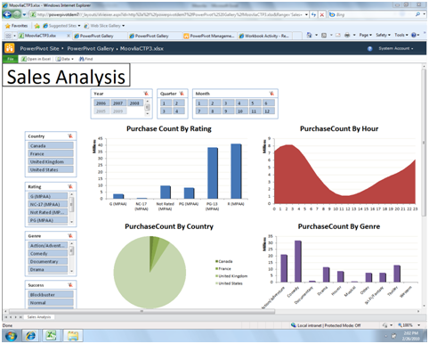

Figure 2 - PowerPivot Model Published to SharePoint Server 2010

## Typical Infrastructure

Strictly speaking, users can create data mashups in Excel or PowerPivot without engaging IT resources. Most users already have Excel and PowerPivot for Excel is available as a free download. Because users often rely on, and are capable of, gathering data from multiple sources, the need for a structured corporate system to be built, such as a data warehouse, may be reduced.

However, just as they can with the self-service reporting and analysis style, IT can play an important role in the self-service data mashup style by providing and managing supporting infrastructure. To enable users to share Excel or PowerPivot workbooks, IT needs to implement SharePoint Server 2010 Enterprise Edition with PowerPivot for SharePoint installed and Excel Services enabled. If the organization wants to promote PowerPivot data mashups to IT managed solutions, Analysis Services must be installed in tabular mode.

## Key Considerations

The questions in the following table may help you identify which tool to use for the self-service data mashup style.

|  | **Excel** | **PowerPivot for Excel** |
| --- | --- | --- |
| **What is your primary intent?** | We need to combine and analyze a few small to medium sized datasets. | We need to explore and analyze large amounts of data from multiple sources. |
| **What is the skill level of the users?** | Users are familiar with Excel VLookup and HLookup functions. | Users understand how to create column-based relationships between tables, and they understand DAX. |
| **How much data is being analyzed?** | Small to medium data sets (from hundreds of records to just over 1 million records). | Many millions of records. |
| **Is the data coming from multiple data sources?** | Yes.  To incorporate data from multiple sources, you import it into Excel and then integrate one column or row at a time using VLookup or HLookup functions. | Yes.  To incorporate data from multiple sources, you import it into PowerPivot tables and then create relationships between the tables. |
| **Does your data need to be refreshed on a regular basis?** | In Excel, you refresh data manually or create macros. However, you can refresh linked data automatically if the Excel workbook is published to SharePoint Server 2010. | You can update data in PowerPivot for Excel with a single click. You can schedule data to be refreshed automatically if the PowerPivot workbook is published to SharePoint Server 2010. |

## Case Study

### Customer Description

Hitachi Consulting, the global business and IT consulting company of Hitachi Ltd., is a recognized leader in practical business strategies and technology solutions. Hitachi Consulting is an international management and technology consulting firm with headquarters in Dallas, Texas.

### Business Problem

A division within Hitachi Consulting that is involved in managing several large clients needed to gain better visibility into each of its projects in order to properly forecast and adjust to sudden changes. In order to achieve this visibility, this group needed access to additional data sources that did not exist in the corporate project tracking tools. The company already had a significant investment in a Microsoft BI platform and did not want to re-create existing data sources to achieve its reporting needs. Non-value–added work had to be done each month to get the data required to build these reports, and data was often inaccurate and outdated. Additionally, the division’s reporting needs were relatively low in the list of priorities for IT, driving the need to seek different alternatives.

### Tool Choice and Solution Architecture

The team chose to implement a PowerPivot for Excel and PowerPivot for SharePoint Services solution to address its analytical reporting needs. The solution used the existing capabilities of SharePoint Server to capture additional metrics and PowerPivot to build the relationships between multiple data sources. By leveraging these tools, the team was able to build reports using existing corporate metrics and enhance the project and account management reports to improve their forecasting abilities.

One of the main advantages provided by this solution architecture was the skillset of resources needed to build the solution. Instead of using a typical BI stack solution where a full complement of developers, functional analysts, and designer are generally required, the team was able to build the solution with strong data analysts only. The firm's experienced BI resources were only leveraged for specific tasks, such as the data model design, advanced calculations (called DAX - Data Analysis Expressions – which is an expression language based on Excel formula syntax used in PowerPivot), and SharePoint Server expertise for some of the data capture mechanisms and workflows desired as part of the overall solution that was delivered. This solution was initially rolled out to approximately 20 users. It was so well received that the Operations Management leadership funded a next release of the PowerPivot model to expand the reporting capabilities and support adoption of corporate processes – which will result in the addition of another 50 users or more. This release also paves the way for the model to be used more broadly in other divisions across the company.

### Benefits Realized

The division was able to benefit right away from this solution. Person-hours used to gather the data every month were phased out and the division gained operational efficiencies. With an automated refresh of the data, the team had better access to the information they needed in a timelier manner. Additionally, data quality problems were mitigated and communication with corporate billing was improved. Finally, by implementing this solution, the team was able to gain the visibility they needed to more efficiently manage their projects, allowing them to quickly adapt and plan when projects were not on track.

## Summary

Excel meets the basic needs of power users who want to combine and analyze data from multiple sources. However, Excel used alone is limited in its scalability, and it does not allow for IT to manage the environment. Excel 2010 used with the PowerPivot add-in and combined with PowerPivot for SharePoint 2010 provides a scalable and managed environment while still offering users the flexibility to acquire and integrate data from a variety of sources and build and share their own reports and dashboards. Power View reports can be based on PowerPivot workbooks that have been published to SharePoint, and PowerPivot workbooks can easily be migrated to Analysis Services 2012.

# Professional Reporting

## Description and Key Characteristics

While typically not as fluid or fun as the self-service creations discussed earlier, Professional Reporting is just as important to organizations because of the need to create highly formatted and distributable reports. Reports such as daily, weekly, or monthly sales reports need to be distributed to the responsible parties for each store, region, or other organizational entity in a timely manner and without requiring user involvement to locate and run the report. Some key characteristics of the Professional Reporting style are:

* Data used to create reports comes from corporate-sanctioned and IT-managed data sources.
* Reports are highly formatted and may be frequently printed.
* Reports are usually created to fulfill specific requirements. Users are provided a guided navigation experience where a report may include parameterized filtering and sorting. Users can also drill down, drill through, and drill across to related reports. Full ad-hoc interactivity is not available.
* Power users from the business community can create reports, but users may need to have experience with SQL, MDX, or other query languages as well as technical report development skills to create more complex reports.
* Reports are often shared with a team or across the entire organization.
* Reports are scheduled to be refreshed and distributed to users via email or are available on-demand with live interactivity using a web browser.
* Reports may be delivered in multiple formats such as PDF, Excel, Microsoft Word, HTML, and so on.
* Reports may be embedded in line-of-business applications.

## Tool Options

Although it is possible to address many of the characteristics of this style with several of the Microsoft BI tools, SQL Server Reporting Services is the best fit for this style, because it handles all of the requirements and is the only tool that addresses automatic distribution of reports.

### [Microsoft SQL Server 2012 Reporting Services](http://www.microsoft.com/sqlserver/en/us/solutions-technologies/business-intelligence/reporting-services.aspx)

Microsoft SQL Server Reporting Services provides a complete, server-based platform designed to support a wide variety of reporting needs, enabling organizations to deliver relevant information where needed across the entire enterprise. Through a powerful report authoring and management environment, Reporting Services enables IT to create and manage both static and parameterized reports and provides a solid platform for delivering information throughout the organization. The same report can be made available via portal or automatically generated and distributed via Reporting Services.

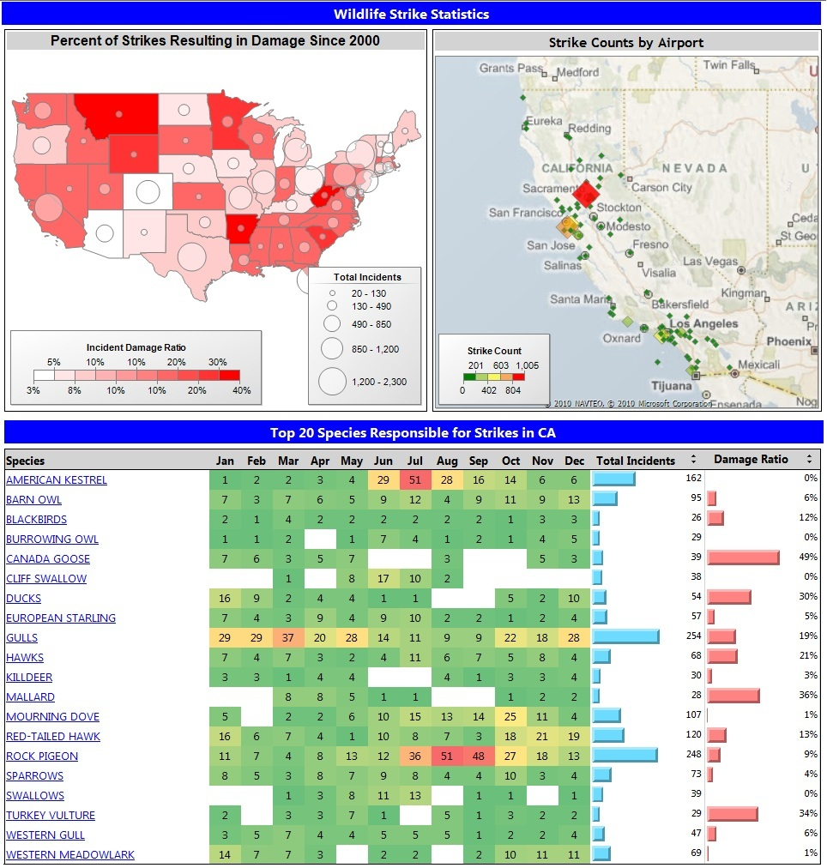

Figure 3 - SQL Server 2012 Reporting Services

When the report is accessed via portal, end users can interact and perform analysis through the use of parameters and filters embedded in the reports. With the use of parameters, drill-down, and drill-through capabilities, users can perform more guided reporting and analysis. Additionally, reports can be linked together to support more in-depth analysis via drill-across capabilities.

Using the report distribution components of Reporting Services, a single report format can be created and distributed to users or user groups with the data specific to their role. This adaptability allows reports to be scheduled and distributed throughout the organization using different delivery mechanisms and different rendering formats, depending on the needs of the user community. The reports can be delivered via portal, file share, or email, or they can even be sent directly to a printer, and they can be generated as PDF, Excel, XML, comma-delimited text file, TIFF image, HTML or Microsoft Word formats.

## Typical Infrastructure

Report developers in an IT department or power users in a business unit can create Reporting Services reports. IT report developers can use SQL Server Data Tools to create reports within the Microsoft Visual Studio 2010 integrated development environment. Using SQL Server Data Tools, these users can embed Reporting Services reports into custom applications, collaborate with others and manage report versions using a source code control application, and use other professional development tool add-ins.

Business users can develop reports using Report Builder, which provides a full-featured reporting environment that allows users to develop highly formatted reports using an Excel-like ribbon. One of the biggest advantages of Report Builder is that it supports all of the reporting features that are available in SQL Server Data Tools so that business authored reports can be seamlessly integrated into an IT managed reporting environment. Additionally, Report Builder enables sharing and reuse of objects for faster report development with Report Parts.

For this style to be utilized effectively in an organization, there should be an IT department in charge of creating and managing the corporate data sources such as data warehouses or data marts. The IT department should be experienced dealing with BI structures and reporting technologies, and it should plan to be heavily involved in report development and management, including having a firm grasp on using reporting tools and query languages such as SQL, MDX, and DAX.

## Case Study

### Customer Description

The customer in this example wishes to remain anonymous, but is a large regional commercial bank in the southwest that delivers highly personalized financial services to businesses and private client individuals.

### Business Problem

The bank had limited visibility across all customers’ transactions, lines of business, and relationships. Additionally, transaction-level information on the various bank products existed in a multitude of different systems, resulting in a partial view of their customers’ overall relationship with the bank. The inability to develop a concise customer view across multiple lines of business was limiting the bank’s ability to identify opportunity for growth or new products. Rather than having applicable information automatically available to the Customer Relationship Managers (CRMs) to help serve the customer better and accordingly increase bank revenue, each CRM would spend tremendous amounts of time gathering data from different sources and arranging the data into their own unique formats.

### Tool Choice and Solution Architecture

In order to solve this problem, the client implemented a customer data warehouse to hold all its customers, accounts, and transactional information. The data warehouse consolidated 14 separate source systems into a single data repository. Reporting Services reports built on this consolidated data provided consistent reporting and information to all CRMs across the organization. CRMs were able to run a report interactively when needed for analysis, and to create personal subscriptions to reports and receive the reports tailored to their parameters and preferences automatically on schedule.

### Benefits Realized

Microsoft SQL Server Reporting Services reports implemented on top of a new data warehouse introduced new sales capabilities by providing CRMs with the appropriate information at the right time.

The benefits of the combined customer reporting included solid and timely support to the CRMs to help them sell products more effectively supported by a consolidated view of all the products owned by a customer regardless of the source. It also helped them to grow business in specific asset classes and to generate additional revenue by strategically investing customers’ money into higher-yielding products.

Through analytical reporting and the comprehensive view of products and services, CRMs were able to attract and retain deposits, increase loans as deposits allowed, and mitigate their risk through exposure across product lines and industries.

By being able to run these precreated parameterized reports on their own without the need of an analyst, Customer Advisors could identify opportunities in a timely manner and act accordingly.

## Summary

Reporting Services is the clear tool of choice for Professional Reporting. By providing automatic report generation and distribution, and by providing users with guided analysis of the data, Reporting Services leverages the capabilities of IT infrastructure and takes into account the varying expertise and desires of the user community, delivering a solution tailored to match each user’s needs.

# Performance Monitoring (Dashboards)

## Description and Key Characteristics

Just as a dashboard in a car helps a driver quickly understand the real-time operational performance of the automobile, a dashboard report helps business decision makers understand the current health of their business. A dashboard often combines key performance indicators (KPIs) from various business functions on a single page to help provide an at-a-glance view of performance and the ability to drill down further when something is off track or performing extremely well. This style is called “Performance Monitoring (Dashboard)”. This style is generally found in more mature BI environments where data points of interest have been defined, key determinants of business success have been identified, and a comprehensive BI strategy exists. The following are key characteristics that describe this style:

* Reports provide an at-a-glance view of business performance.
* Reports provide a more holistic view of the business or business function by combining multiple types of content together.
* Data in multiple formats is combined on one page. Some examples might include a tabular report with sparklines, along with trended graphs or bar charts, and geospatial maps or scorecards.
* Users can drill down to perform root-cause analysis for data anomalies.
* A corporate data platform is in place and often includes an OLAP component, all refreshed regularly.
* Reports are often deployed broadly to decision makers at various levels in the organization, from front-line workers, who need to make real-time operational decisions, to managers and executives, who need to make tactical and strategic decisions.

## Tool Options

A variety of tools can be used to create dashboard reports to support this style of reporting. SharePoint Server is a common thread across all of the tools and the recommended platform for delivering dashboards. Because this style encourages the use of multiple formats combined on one page, it is not unusual to use more than a single technology to support this style. This section discusses all of the Microsoft tools and focuses on the benefits and trade-offs of using each technology choice.

### [Excel Services](http://technet.microsoft.com/en-us/library/ee424405.aspx) / [PowerPivot for Excel](http://www.microsoft.com/en-us/bi/powerpivot.aspx)

Excel can be used to author dashboards, which can then be shared via two different methods. Excel Services uses a standard Excel workbook which is then hosted on SharePoint Server for viewing; however, it is limited in interactivity and is not designed for automated data refreshes. PowerPivot for Excel also provides interactivity and automated data refreshes. Using PowerPivot, you can easily consolidate multiple data sources into a single dataset and work with much larger data volumes.

In Excel it is easy to incorporate sparklines, red/yellow/green indicators, charts, and grids all on one page, so it is a popular choice for dashboards. Furthermore, mentioned in the discussion of the self-service analysis style, Excel has the ability to integrate both IT-managed sources and nonmanaged sources. This can prove valuable for incorporating elements onto the dashboard like industry competitive information that may not be integrated into the corporate data structures.

### [Microsoft SQL Server 2012 Reporting Services Power View](http://social.technet.microsoft.com/wiki/contents/articles/3726.power-view-overview.aspx)

Power View enables business users to easily create reports, and they can use Power View to create simple dashboards that contain a variety of charts and tables. However, Power View was not designed as a dashboarding tool and doesn’t provide as many capabilities as the other tools discussed in this section. While Power View provides the ability to create many effective data visualizations, it does not yet include sparklines, red/yellow/green indicators, conditional formatting, geospatial visualizations, gauges, drill-down, or drill-through. For these reasons, Power View is not recommended as a dashboarding tool.

### [PerformancePoint Services](http://technet.microsoft.com/en-us/library/ee661741.aspx)

The PerformancePoint Services component of Microsoft SharePoint Server 2010 is a performance management tool that is used to create dashboards and scorecards. By providing flexible, easy-to-use tools for building dashboards, scorecards, reports, and key performance indicators (KPIs), PerformancePoint Services can help users across your organization make informed business decisions that align with companywide objectives and strategy. PerformancePoint Services provides the ability to pull multiple types of data visualizations into a single dashboard. Users can interact with Reporting Services reports, cube-based graphs, performance maps, decomposition trees and Microsoft Visio diagrams. Other content types can even be integrated by displaying any web page desired within a frame of the dashboard. As you can see in Figure 4, this flexibility in reporting gives users ample ways to navigate through the organization’s data and derive new information that is useful in making decisions.

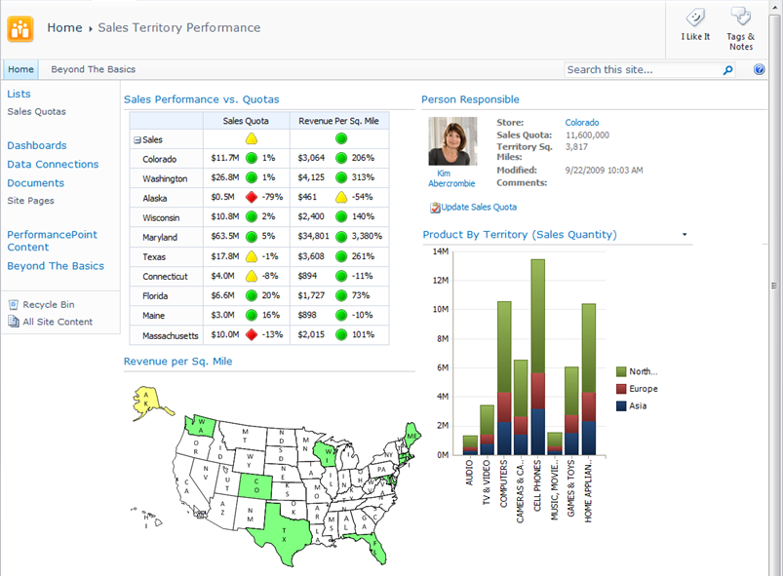

Figure 4 - PerformancePoint Services in Microsoft SharePoint Server 2010

Dashboard filters can be applied across the dashboard components, enabling users to update multiple or all parts of a dashboard simultaneously. With cube-based graphs and charts, users can perform ad-hoc analysis, slice and dice dimensional data, navigate through hierarchies, and pivot and change chart types quickly and seamlessly in just a few clicks. This type of analysis enables users to interact with the data and gives them the ability to arrive at answers that may not be available at first glance. PerformancePoint Services dashboards can incorporate data from a variety of sources, providing the capability to develop and manage the presentation of reports through one tool. In addition, report and dashboard development can be performed much faster through use of the structured layout and predefined design options available in PerformancePoint Services.

### [Microsoft SQL Server 2012 Reporting Services](http://www.microsoft.com/sqlserver/en/us/solutions-technologies/business-intelligence/reporting-services.aspx)

As described in the Professional Reporting Style earlier in the paper, Reporting Services provides a powerful report authoring design environment. One of the key features of that design environment is the ability to integrate multiple data sources and report styles on a single page. Reporting services supports sparklines, geospatial reports, charts, grids, and so on. Dashboards can be authored completely within Reporting Services, and guided navigation can be included through drill-down features and drill-through reports. Another benefit of authoring dashboards completely within Reporting Services is the enhanced printing and export abilities of Reporting Services, plus the report distribution capabilities. The downside of authoring in this environment is that drill-down navigation paths have to be predetermined and prebuilt, and the complexity involved in implementing most full-featured dashboards in Reporting Services requires the involvement of technical resources.

## Typical Infrastructure

The Performance Monitoring style capitalizes on existing data structures, often enterprise-wide, that serve as the repository for information from multiple data sources. The existence of OLAP cubes forms the foundation of BI analysis in these environments. Data is typically refreshed on a regular schedule to provide the most current information possible to the users. For these reasons, an IT department is required to deliver and support the BI needs of the organization.

## Key Considerations

The following table provides guidance on some of the trade-offs in using each of the technologies for this style.

|  | Excel Services / PowerPivot for Excel | Reporting Services | PerformancePoint Services |
| --- | --- | --- | --- |
| What is your primary intent? | We want to enable our business users to create dashboards. These dashboards will have limited distribution. | We want dashboards that have professional reporting design, data refresh, distribution, and management capabilities. These dashboards will be created by power users or IT developers. | We need extensive interactivity with dashboard items linked together, access to Decomposition Tree, slice-and-dice, change displays. These dashboards will be created by power users or IT developers. |
| How important is look-and-feel …    versus … | Requires Pivot Tables or CubeCell functions to get data from cubes. You can use the full power of Excel for formatting. | Highly customizable. Complex reports can be created. | Component layout is customizable, but this tool offers less control of look and feel than Excel and Reporting Services. |
| How important is interactivity? | PivotTable interactivity for slice-and-dice. | Preconfigured filtering, sorting, and guided navigation capabilities. | Extensive ad hoc interactivity with dashboard items linked together, access to Decomposition Tree, slice-and-dice, change displays. |
| Is highly formatted printing needed? | Printing is possible but may require some work to setup print areas that are functional during drill-down scenarios. | Reports can be configured for easy printing. Reports can also be exported to different file types (Excel, PDF, and PowerPoint). | Printing and exporting to different file types is limited and can be difficult. This tool is primarily designed for online viewing and interactivity. |
| Do you need to integrate non-corporate sourced data on the dashboard? | You can easily integrate corporate and noncorporate data on the same dashboard. | Limited ability for sourcing external data. | It is possible to integrate both types of data on the same dashboard, You can integrate data from Excel / PowerPivot and Reporting Services. |
| Does the dashboard need advanced visualizations? | Display is limited to Excel PivotTables and PivotCharts. | Reporting Services provides the ability to include Reporting Services Geospatial visualizations, charts and gauges. | This tool offers a wide variety of visualizations including: Visio Services, decomposition trees, Geospatial, weighted Scorecards, and KPIs. |

## Case Study

### Customer Description

Charlotte-Mecklenburg Schools (CMS) is a local education agency headquartered in Charlotte, North Carolina and is the public school system for Mecklenburg County. With over 133,600 students enrolled, it is the second-largest school district in North Carolina and the twentieth-largest in the nation.

### Business Problem

CMS was tracking performance manually, and only a few times a year. The Board of Education would ask for custom, ad-hoc reports that required significant district resources to produce and that offered very little transparency into program effectiveness. With limited resources, rapid growth, and hundreds of different programs, CMS was finding it difficult to get real-time access to performance data so that it could make better decisions.

### Tool Choice and Solution Architecture

CMS chose to implement a dashboard solution by using PerformancePoint Services. A series of dashboards were deployed to a publicly accessible SharePoint site, enabling the Board of Education, the central office, and parents to monitor whether improvement efforts were on track. These dashboards take advantage of the abilities of SharePoint Server and PerformancePoint Services to combine scorecards, dashboards, and reports into a consolidated view. Data for the dashboards is sourced from CMS’s data warehouse, Excel spreadsheets, and departmental and organizational systems.

### Benefits Realized

CMS was able to quickly benefit from implementing this solution in several ways. Users can track CMS progress towards each goal, enabling them to make better decisions about which initiatives to pursue. The Board of Education and district workers can analyze and compare performance data along many dimensions, such as race, income level, and English-language proficiency. By deploying the tool internally and out to the district’s constituents – a community of close to a million members – CMS was able to increase transparency district-wide and throughout the community. Additionally, real-time information enables the Board of Education to see whether CMS is likely to meet, exceed, or fall short of its performance goals – and make timely adjustments to stay on track. Finally, the PerformancePoint Services solution provides CMS with the scalability and affordability needed to support their aggressive growth goals.

## Summary

Many tools can be used to support the Performance Monitoring style, and each tool comes with its own set of benefits and trade-offs. Although the choice of which dashboard tool to use depends upon how each measures up against the specific set of requirements, SharePoint Server is the common denominator across all the tools and provides a single point of entry for the Performance Monitoring style.

Excel is a business-friendly report authoring environment and provides the ability to integrate data in your dashboards that may or may not exist in the corporate IT platform. Combined with Excel Services and PowerPivot for SharePoint, it is also the simplest means for business users to create and share their own dashboards without IT involvement.

Reporting Services provides the advantage of greater layout flexibility during dashboard report development and provides excellent printing capabilities. Reporting Services allows greater report structure for guided navigation, although this may be viewed as a strength or weakness depending on how sophisticated the end users are and how much leeway you want to provide them to analyze on their own.

PerformancePoint Services provides the most interactive and flexible data analysis capabilities. Charts and graphs in a dashboard can be connected to interact with each other, and filters can be applied to multiple reports on the same page that have been created in different technologies. Ad-hoc interactive analysis is quick and easy when the source is an Analysis Services cube. The flexibility in a PerformancePoint dashboard limits the formatting options for printing, but it empowers users to analyze the data and find new and different ways of displaying the information.

# Scorecarding

## Description and Key Characteristics

Just as baseball fanatics diligently keep stats on their favorite players and teams and monitor key indicators on their achievement, organizations track statistics on the clearly articulated set of metrics that measure and monitor businesses performance in achieving their strategic objectives. *Scorecarding* describes this BI style, in which users measure enterprise-wide performance against organizational goals, and where the timely presentation of trends and key performance indicators (KPIs) is critical in driving business decisions.

The following characteristics describe this style:

* A small number of KPIs are identified and monitored against articulated targets.
* The relative importance of KPIs is known and weighted to provide an overall score for an organization, department, or individual’s performance.
* Business objectives and their related KPIs are presented hierarchically and can be filtered to help determine root causes of outliers.
* A corporate data platform is in place and often includes an OLAP component, all being refreshed regularly.
* The scorecard is often broadly deployed and can be easily consumed and navigated with a browser.

## Tool Options

Excel, Reporting Services, and PerformancePoint Services can all be used to create scorecards, and each tool comes with benefits and trade-offs, which have largely been discussed in other styles. However, of the group, only PerformancePoint Services is a true scorecarding platform and therefore is the recommended tool for creating scorecarding solutions.

### [Excel](http://blogs.technet.com/b/office2010/archive/2010/01/28/business-intelligence-features-in-excel-2010.aspx) and [PowerPivot for Excel](http://www.microsoft.com/en-us/bi/powerpivot.aspx)

Excel and PowerPivot for Excel can be used to create free-form scorecard style reports; however, building a comprehensive scorecard solution requires extensive development.

### [Reporting Services](http://www.microsoft.com/sqlserver/en/us/solutions-technologies/business-intelligence/reporting-services.aspx)

Like Excel, Reporting Services is a great choice for creating reports that look like a scorecard, but creation of the weighted indicators or multiple rollup types that are required for a full-featured scorecard solution requires complex development.

### [PerformancePoint Services](http://technet.microsoft.com/en-us/library/ee661741.aspx)

PerformancePoint Services is a component of SharePoint Server 2010 and provides a platform for designing and building both balanced and free-form scorecards.

*Balanced scorecards* are a strategic planning and management system that was made famous in the early 1990s by Kaplan and Norton when they wrote the book *Balanced Scorecard: Turning Strategy into Action.* Balanced scorecards focus the organization on finding a set of metrics across multiple perspectives – balancing the typical lagging financial indicators with a broader set of leading indicators that better predict future performance.

Balanced and free-form scorecards, along with strategy maps, enable organizations to provide a concise vehicle for communicating overall company performance and comparing that performance to well-defined targets. A major benefit of scorecards is the ability to aggregate and display disparate data into unified and summarized scores.

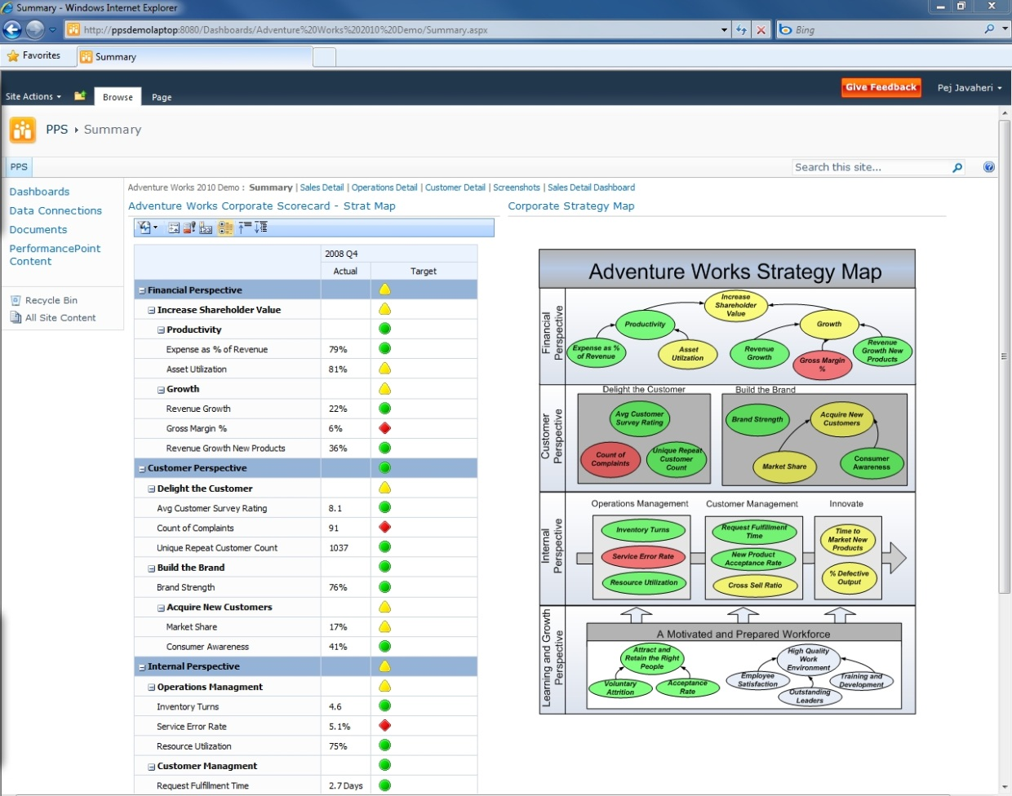

Figure 5 - Scorecarding with PerformancePoint Services in Microsoft SharePoint Server 2010

As shown in Figure 5, PerformancePoint Services enables companies to set up hierarchical KPIs with relative weightings that align with perspectives and objectives. Targets can be defined at each intersection and ranges can be set for defining Red/Yellow/Green status thresholds for each KPI. Because PerformancePoint Services is a part of SharePoint Server 2010 – the scorecards are easily shared and distributed. Scorecards can also be pivoted and filtered by a number of dimensions, enabling users to perform root cause analysis on KPIs that are not meeting the targets. Scorecards are often displayed as a component within in a dashboard, and they can leverage the full-power of the Performance Monitoring Style by interacting with other reports in the dashboard.

## Key Considerations

PerformancePoint Services is the preferred platform for full-featured scorecards; however, all of the Microsoft BI tools can be used for this style if creating scorecard-style reports is the main objective. The following table discusses the key considerations that differentiate the tools for this BI style.

**Note:** Refer to the Key Considerations of the “Performance Monitoring (Dashboard)” style to evaluate the other aspects of the tools. That analysis is not discussed here to avoid repetition, because the Scorecard style is essentially always presented as a component of a dashboard.

|  | Excel Services /  PowerPivot for Excel | Reporting Services | PerformancePoint Services |
| --- | --- | --- | --- |
| Informal scorecard style reporting | Yes – Scorecard Style reporting. | Yes – Scorecard Style reporting. | No –KPIs defined on formal data sources or in PowerPivot for Excel first. |
| Does the scorecard require true scorecard platform capabilities? | No – scorecard-style reporting only. | No – Scorecard-style reporting only. | Yes – Can define KPIs, custom aggregations, weightings, and threshold configurations. |
| Does the scorecard need to drive other reporting styles? | No – Scorecard-style reporting only. | No – Scorecard-style reporting only. | Yes – KPIs drive navigation of other report styles in the dashboard. |

## Case Study

### Customer Description

Schumacher Group is the world’s third-largest and fastest growing provider of healthcare emergency medical services. It is focused on serving hospital clients and clinicians, providing emergency medicine, staffing, and management services.

### Business Problem

The operations department of Schumacher Group was faced with a series of reporting problems and needs at all levels across the department. They experienced inconsistent reporting, which made it difficult for users to share and compare reports. Reports were created manually, which added additional room for error, caused analysts to spend more time creating the reports and less time analyzing the data, and resulted in reports with data which was often outdated. In addition, users spent time questioning the integrity of the data and often had to spend time validating information shown on the reports.

### Tool Choice and Solution Architecture

Schumacher chose to implement a balanced scorecard solution for its operations department. The solution included a dashboard with a consolidated scorecard reporting across four perspectives of the organization: Financial, Operation, Clinical, and Customer Service. KPIs were created, providing a concise and meaningful picture of performance to all levels of the organization. Drill-to-Detail reports were also deployed, providing users with the ability to investigate root causes of poorly performing KPIs. Links directly from the scorecard to SharePoint Server documentation and training materials were created. Finally, all information was consolidated and cleansed through a central repository and updated nightly.

### Benefits Realized

Schumacher was able to take advantage and benefit from implementing PerformancePoint Services right away. Performance throughout the organization was improved due to consistent and transparent reporting in all four key areas of the organization (Financial, Operational, Clinical, and Customer Service). Additionally, productivity was improved due to reliable and up-to-date information. Finally, the business quickly identified poorly performing areas and implemented plans to improve performance.

## Summary

Scorecarding is the most mature of all BI styles, enabling organizations to track trends and KPIs over a period of time and against company-defined targets. Although all of the Microsoft BI tools offer scorecard-like reporting, if you choose PerformancePoint Services, you can create scorecards by using a methodology such as balanced scorecards, or you can define and apply your own methodology. PerformancePoint Services facilitates weighted score rollups, measurement against targets, and predefined KPIs, in addition to providing the broader set of PerformancePoint functionality to allow integrating the scorecard into a dashboard alongside other reporting and analysis capabilities.

# Conclusion

In today’s fast paced and ever changing world, organizations have a need to provide the right information to the right person at the right time. Doing exactly that is a fundamental promise of a BI program; however, if the reporting and analysis tools are not properly aligned to the information consumption and analysis needs, any solution is in danger of missing the mark entirely and failing to provide the anticipated value.

Microsoft provides a variety of reporting and analysis tools to fit a variety of situations. This paper explains that none of these is always the right answer for every style of reporting, nor is there always a clear choice for a given style. But the guidance that has been presented should assist you in making practical decisions about which tool is the best fit for each of your reporting needs, given your own unique set of circumstances. More importantly, with the tools you own today you can address all of the styles you are likely to encounter in your organization.

Figure 6 offers a visual summary of the tools that best fit each style, including the groups of users who are best able to use the tool or tools effectively.

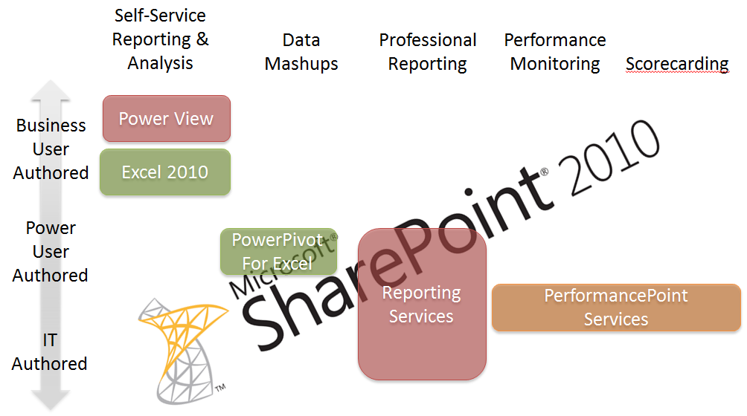

Figure 6 – Choosing the right Microsoft reporting and analysis tool

# Additional Resources

**Web Sites**

* For more information about the Microsoft BI tools, see <http://www.microsoft.com/bi>.
* SQL Server PowerPivot 2012 is available as a free add-in to Excel 2010. Managed self-service BI is enabled with PowerPivot for SharePoint. For more information, see <http://www.microsoft.com/en-us/bi/powerpivot.aspx>.
* Microsoft SQL Server 2012 Reporting Services provides a complete, server-based platform designed to support a wide variety of reporting needs. For more information, see <http://www.microsoft.com/sqlserver/en/us/solutions-technologies/business-intelligence/reporting-services.aspx>.
* Microsoft SQL Server 2012 Reporting Services Power View enables all users to easily explore data and create sophisticated reports. For more information, see <http://social.technet.microsoft.com/wiki/contents/articles/3726.power-view-overview.aspx>.
* The PerformancePoint Services component of Microsoft SharePoint Server 2010 is a performance management service that is used to create dashboards and scorecards. For more information, see <http://technet.microsoft.com/en-us/library/ee661741.aspx>.

**Case Studies**

* Great Western Bank: <http://www.microsoft.com/casestudies/Case_Study_Detail.aspx?CaseStudyID=4000011340>
* Chevron: <http://www.microsoft.com/casestudies/case_study_detail.aspx?casestudyid=4000007043>
* Charlotte-Mecklenburg Schools: <http://www.microsoft.com/casestudies/Case_Study_Detail.aspx?CaseStudyID=4000002234>
* Schumacher: <http://www.hitachiconsulting.com/files/pdfRepository/CS_SchumacherGroup.pdf>

For more information about additional case studies, see <http://www.microsoft.com/sqlserver/en/us/learning-center/case-studies.aspx>.

# For More Information

[SQL Server Website](http://www.microsoft.com/sqlserver/)

http://www.microsoft.com/sqlserver/

[SQL Server TechCenter](http://technet.microsoft.com/en-us/sqlserver/)

http://technet.microsoft.com/en-us/sqlserver/

[SQL Server DevCenter](http://msdn.microsoft.com/en-us/sqlserver/)

http://msdn.microsoft.com/en-us/sqlserver/

Did this paper help you? Please give us your feedback. Tell us on a scale of 1 (poor) to 5 (excellent), how would you rate this paper and why have you given it this rating? For example:

* Are you rating it high because of having good examples, excellent screenshots,   
  clear writing, or another reason?
* Are you rating it low because of poor examples, fuzzy screenshots, or unclear writing?

This feedback will help us improve the quality of white papers we release.

[Send feedback](mailto:sqlfback@microsoft.com?subject=White%20Paper%20Feedback:%20How%20To%20Choose%20the%20Right%20Reporting%20and%20Analysis%20Tools%20to%20Suit%20Your%20Style).